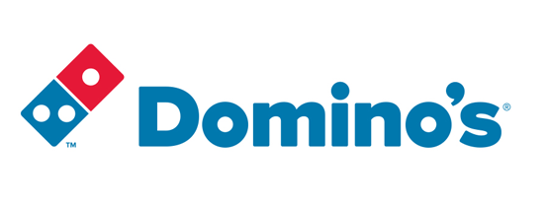

\

|  |
| --- |
| **Domino’s Supply Chain Case Study** |
|  |

|  |  |
| --- | --- |
| **By:** Sarah Al-Sharif Milkias Demissie  Ali Khazaei Casey Valentine | **Advisor:** Dr. Hoffman **Sponsor:** Dr. Charbonneau  OR/SYST 699 – Fall 2015December 11, 2015 |

# Pizza in America

ingredients to make one pizza consisting of dough, tomato sauce, and cheese for a price of $3.96. This price includes material cost, profit, labor cost, transportation cost, royalty, and ad contribution costs.

# The Birth of Domino’s

Today, Domino’s has 5,098 stores in the US.

# Domino’s Supply Chain

Domino’s Supply chain divided into three main tiers. Tier2 is comprised of Domino’s key suppliers to Domino’s distribution centers. Tier 2 includes nine Leprino’s foods cheese suppliers, three Paradise tomato sauce suppliers, thirty eight Ardent Mills flour supplier and two Domino’s thin crust bread and veggie supplier center. Tire 2 supplies pizza ingredients cheese, tomato sauce, flour, thin crust bread to tier1 (Domino’s Distribution centers). Tier1, direct suppliers to tier 0, is comprised of 16 Domino’s distribution centers. Tier1 supplies the pizza ingredients to Tier 0 (5098 Domino’s stores). Tier 0 is the final product makers to supply the consumers.

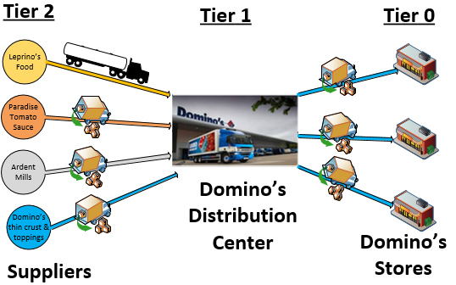

Figure 4: Domino’s Supply chain tiers

In order to control the quality standards of its products Domino’s has strict requirements on ingredients, assembly, and cooking of its products. To maintain quality standards, the company requires franchise stores to purchase the dough, cheese, and sauce from its corporate distribution centers. Dough is made at the distribution centers to further ensure consistency and reduce preparation activities at stores.

## The Domino’s Pizza Supply Chain Case Study

In the conduct of this case study you will:

* Formulate, model, and solve large scale transportation and facility location problems using Integer Programming (IP),
* Gather required data by creating a web crawler and scraping web pages
* Transform data into usable information via Google, MapQuest, and/or Bing API’s
* Manage and manipulate large data sets and transform them into parameters used by your LP formulation.
* Understand Vehicle Routing Problems (VRPs), and the characteristics which make the design, program, and apply heuristic methods for generating “good solutions” to the VRP.

This case study is laid out into seven sections:

**Section 3:** describes commissary system for maintaining quality assurance and efficiently distributing its ingredients to all of its stores. Also describes the details on Domino’s   
 stores and distribution centers are included.  
**Section 4:** provides details concerning the flour, cheese, and tomato sauce suppliers  
**Section 5:** describes the transportation system.  
**Section 6:** provides the assumptions, restrictions, limitations that (also known as constraints) that you will need to incorporate into your data gathering and model formulation.

**Section 7:** contains the list of problems you will be solving in this class with key data dispersed throughout the case study.

## Domino’s Stores

There are 5098 Domino’s stores in US. Each store receives a bi-weekly delivery of pizza ingredient and other store consumables from Domino’s distribution center. Domino’s stores use these ingredients to make regular and thin crust pizzas. The recipes for both regular and thin crust pizza are given below.

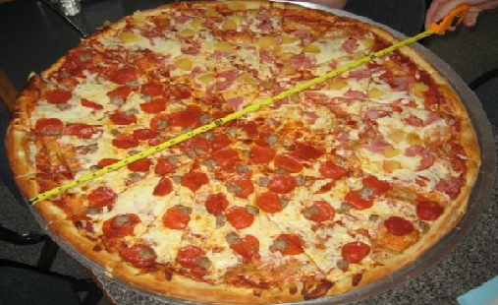

***How to make 16’’ Domino’s regular Pizza in the store?***

1. Press 14.6 Ounce dough into an oiled 16-inch pizza pan
2. Top each with 1.5 cup Paradise tomato sauce,
3. Sprinkle with 2.25 cups shredded Leprino’s cheese.
4. Bake until the cheese melts, then drizzle with olive oil.

Figure 5 : Domino’s 16 pizza

***How to make 14’’ Domino’s thin crust Pizza in the store?***

1. Place the 14’’ thin crust bread into an oiled 14-inch pizza pan
2. Top each with 1.5 cup Paradise tomato sauce,
3. Sprinkle with 2.25 cups diced Leprino’s cheese.

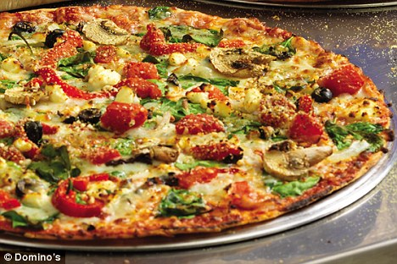

1. Bake until the cheese melts, then drizzle with olive oil.

Figure 6: Domino’s thin crust pizza

The average daily sells for regular Domino’s pizza accounts 72% of the total pizza sells and thin crust pizza accounting the remaining 28%.

## Distribution Centers

Domino’s has 18 distribution centers, 16 of which supply all Domino’s stores with necessary pizza ingredients and other store consumables. The 16 Domino’s distribution centers continuously supply dough, cheese, sauce and thin crust bread. Domino’s also operates two specialized distribution centers that handle all demand for thin crust pizza and toppings. These two special Domino’s distribution centers will be discussed Section 4.

Domino’s distribution centers are strategically located around the US so it can reach all stores within a one day delivery window. On average each Domino’s distribution centers area is about 20,000 square feet [12]. This area includes dough manufacturing area, space to store refrigerated pallets to store boxes of cheese, box of thin crust breads shipped from the suppliers and tray of dough. The distribution center also stores flours, tomato sauce and other consumable material on pallet of size 48’’ x 40’’x12’’in none refrigerated section of the distribution center.

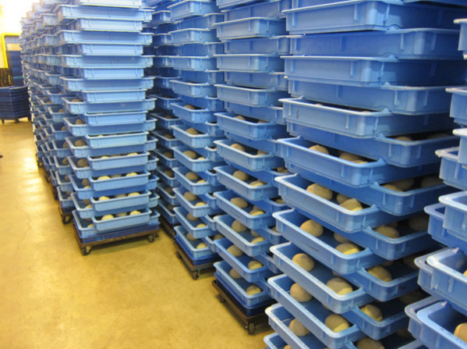

Figure 7: Stack of dough tray in distribution center

These distribution centers have the capacity to manufacture and distribute regular doughs to meet the demand of Domino’s stores they cover. Doughs manufactured here will be stored in tray box on a rack inside refrigerated section of the distribution center before shipped to the stores.

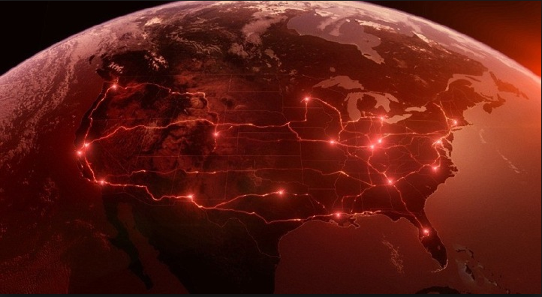

Figure 8: The 18 Domino’s distribution centers

Locations and capacities of each of the 16 Domino distribution centers are given in the table below. Distribution center capacities are also given in pizzas per week with the distribution center being capable of manufacturing and redistributing ingredients to meet the pizza capacity. Distribution centers service franchise stores twice a week with fresh pizza ingredients [9].

Table 1: Domino's distribution center location and dough supply capacity

|  |  |  |  |  |
| --- | --- | --- | --- | --- |
| Distribution Center IDs | Address | Latitude | Longitude | Supply Capacity  (pizza/week) |
| DC 1 | 17605 Commerce Dr.  New Boston, MI 48164 | 42.178616 | -83.391231 | 400,000 |
| DC 2 | 1638 Dolwick Dr.  Erlanger, KY 41018 | 39.056295 | -84.622101 | 350,000 |
| DC 3 | 8271 Anderson Ct  Odenton, MD 2111 | 39.096863 | -76.692468 | 450,000 |
| DC 4 | 3100 Waterfield Dr.  Garner, NC 27529 | 35.679414 | -76.543442 | 350,000 |
| DC 5 | 14 International Dr.  East Granby, CT 06026 | 41.927576 | -72.712023 | 250,000 |
| DC 6 | 4055 ROYAL DR NW,  KENNESAW, GA 3014 | 34.051791 | -84.607207 | 475,000 |
| DC 7 | 1 Cermak Blvd.  St. Peters, MO 63376 | 38.808893 | -90.642824 | 475,000 |
| DC 8 | 3355 Mike Collins Dr.  Eagan MN 55121 | 44.836107 | -93.131175 | 400,000 |
| DC 9 | 7600 American Way  Groveland, FL | 28.636731 | -81.828262 | 400,000 |
| DC 10 | 18251 E Petroleum Dr.  Baton Rouge, LA 70809 | 32.737928 | -97.020135 | 345,000 |
| DC 11 | 900 W Freeway St.  Grand Prairie, TX, 75051 | 32.737928 | -97.020135 | 350,000 |
| DC 12 | 10252 E 51st Ave.  Denver, CO 80238 | 39.790167 | -104.86922 | 350,000 |
| DC 13 | 5216 W Mohave St.  Phoenix, AZ 85043 | 33.431574 | -112.171835 | 300,000 |
| DC 14 | 8005 South 266th St # 101 Kent, WA 98032 | 47.362422 | -112.171751 | 475,000 |
| DC 15 | 30852 San Antonio St.  Hayward, CA 94544 | 37.615432 | -122.047669 | 500,000 |
| DC 16 | 301 South Rockefeller Ave.  Ontario, CA 91761 | 34.061151 | -117.553709 | 350,000 |

### How to make 16’’ regular Domino’s pizza dough

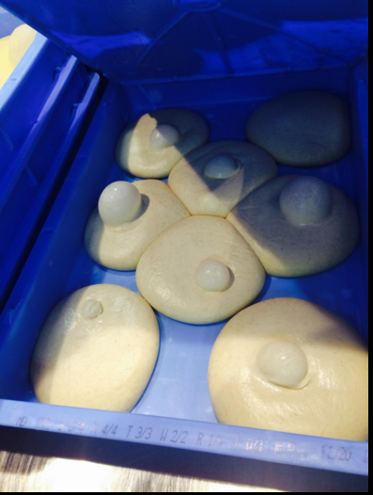

**Regular pizza ingredient [26]:**

* 3 cups flour
* 1/3 tsp salt
* 1 cup of water
* 1 teaspoon sugar

1. In a large bowl, combine flour, salt, baking powder, sugar and water until thoroughly combined.
2. Transfer to a piece of parchment paper and shape into a ball and roll it out paper thin on a piece of parchment paper.

Figure : Domino’s dough transportation tray box.

# Domino’s key suppliers

Domino's is one of the largest domestic bulk purchasers of pizza ingredients such as flour, cheese, sauce and pizza boxes [10]. This allows Domino’s to maximize leverage with its suppliers. The main Domino’s pizza ingredient cheese, flour, and tomato sauce are sourced from different suppliers. These ingredients will be delivered to each Domino’s distribution centers while retaining their quality standards. Domino’s 4 key suppliers are:

1. Leprino’s Foods
2. Paradise Tomato
3. Ardent Mills
4. Domino’s thin crust bread manufacturing distribution center

## Dominos Cheese Supplier:

Cheese is one of the most important ingredients of pizza accounting from 26 to 40% of the pizza price [19]. Domino’s stores consume over 3.5 Million pounds of cheese per week. Domino’s purchase its mozzarella pizza cheese from a single supplier, Leprino Food Company. Leprino’s have nine cheese supply locations throughout US with total supply capacity of 6 Million pounds of cheese per week to meet Domino’s and other cheese market demands.

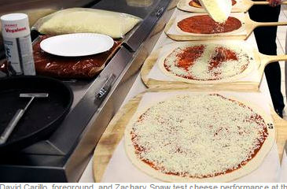

Leprino’s supply quality controlled cheeses to the 16 Domino’s distribution centers bi weekly. Detailed Leprino’s locations, supply capacity and cost of box of cheese are given in table 2.

## Domino’s pizza tomato sauce supplier

The tasty tomato sauce used by Domino’s pizza is supplied by Louisville, KY-based Paradise Tomato Kitchen s [20]. Tomato sauce makes between 12- 16 percent of the total pizza ingredient cost. Paradise which has been named supplier of the year by Domino’s multiple times can supply up to 2.5 Million pound per week of tomato sauce (Estimates) from its 3 location throughout US.

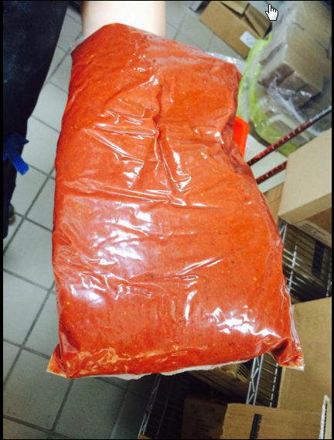

Figure 10: Pouch of Paradise tomato sauce

## Domino’s flour supplier

Ardent Mills is one of the largest flour producing company in US. Ardent mills have 44 milling locations in USA and Canada [23]. Only thirty eight Ardent mills locations in US supplies the flour demands of Domino’s. Domino’s buys around 8 million pound per of flour per week from Ardent Mills. The flour is used to make pizza dough and thin crust bread. Ardent Mill incurs average $750 for facility cost for each of the 38 milling sites in US.

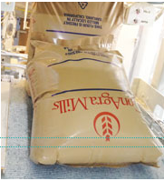

Figure 11 : Ardent Mill 50 lb. flour

## Domino’s thin crust bread supplier

Domino’s in addition to its regular pizza it serves to its customers introduced the crispy thin crust pizza in its menu in 1993[13]. To meet the demand of thin crust pizza, Domino’s has dedicated one distribution center #17 located in Illinois to manufacture and supply thin crust pizza bread. The thin crust bread will be distributed in refrigerated trucks to the 16 Domino’s distribution centers in box. The box of thin crust bread will be shipped stacked over 36’’x36’’x6’’ pallet.   
The detail of Domino’s thin crust bread is shown in table 3:

Figure 12: Pack of Domino's thin crust bread

|  |  |
| --- | --- |
|  |  |

## Suppliers information

The following tables provide list of all 51 suppliers in tier1 with their geographical location and other important data.

Table : List Domino’s suppliers [2,27,28]

|  |  |  |  |  |  |
| --- | --- | --- | --- | --- | --- |
| Store | Address | Latitude | Longitude | Supply Capacity (Unit/week) | Cost per unit ($) |
| Leprino 1 | 5600 Omaha Rd  Roswell NM 88203 | 33.331665 | -104.481049 | 42,857 | 6.46 |
| Leprino 2 | 1302 1st Ave  Greeley CO | 40.416795 | -104.675733 | 42,857 | 6.46 |
| Leprino 3 | 400 rino Ave  Waverly, NY 14892 | 42.010352 | -76.527166 | 60,000 | 6.16 |
| Leprino 4 | 217 Yanuzzi Dr.  Sayre, PA 18840 | 41.99911 | -76.543442 | 42,857 | 7.96 |
| Leprino 5 | 311 N Sheridan Rd  Remus, MI 49340 | 43.594649 | -85.145349 | 38,571 | 7.96 |
| Leprino 6 | 4700 Rich St  Allendale, MI 49401 | 42.978232 | -85.900823 | 51,429 | 6.16 |
| Leprino 7 | 2400 E Beaver Ave  Fort Morgan, CO 80701 | 40.251095 | -103.763711 | 60,000 | 6.46 |
| Leprino 8 | 2401 N MacArthur Dr, Tracy, CA 95376 | 37.755378 | -121.41575 | 47,143 | 7.96 |
| Leprino 9 | 351 Belle Haven Dr, Lemoore, CA 93245 | 36.300217 | -119.821594 | 42,857 | 6.97 |
| Paradise 1 | 1500 S Brook St, Louisville, KY 40208-1950 | 38.224893 | -85.755722 | 10,416 | 12.01 |
| Paradise 2 | 13448 VOLTA RD, LOS BANOS, CA, 936359785, | 37.093404 | -120.920486 | 11,012 | 10.6 |
| Paradise 3 | 1600 Crums ln. Louisville, KY 40216-3826 | 38.188715 | -85.805683 | 8,333.0 | 11.31 |
| Ardent 1 | 4545 E 64th Ave. Commerce City, CO 80022 | 39.81372 | -104.933875 | 7,200 | 35.71 |
| Ardent 2 | 19684 Cajon Blvd  San Bernardino, CA 92407 | 34.198522 | -117.3756 | 11,200 | 34.93 |
| Ardent3 | 1900 Industry Dr. Culpeper, VA 22701 | 38.451794 | -77.989321 | 11,200 | 34.27 |
| Ardent4 | 2050 Market Street NE Decatur, AL 35601 | 34.600933 | -86.958413 | 8,000 | 34.74 |
| Ardent5 | 3939 Producers Dr. Stockton, CA 95206 | 37.9086 | -121.271413 | 11,200 | 35.9 |
| Ardent6 | 200 N Riverfront Dr. Mankato, MN 56001 | 44.16864 | -94.001903 | 9,600 | 34.51 |
| Store | **Address** | **Latitude** | **Longitude** | **Supply Capacity (Unit/week)** | **Cost per unit ($)** |
| Ardent7 | 1521 N 16th St.  Omaha, NE 68110 | 41.27389 | -95.936973 | 11,200 | 34.52 |
| Ardent8 | 2800 Black Bridge Rd. York, PA 17406 | 40.002684 | -76.711711 | 12,800 | 36.12 |
| Ardent9 | 21151 SW 115th Ave, Tualatin, OR 97062 | 45.366716 | -122.796368 | 12,400 | 35.71 |
| Ardent10 | 2020 E Steel Rd  Colton, CA 92324 | 34.061765 | -117.292624 | 7,200 | 34.68 |
| Ardent11 | 2780 G Ave,  Ogden, UT 84401 | 41.215179 | -111.997595 | 11,200 | 35.71 |
| Ardent12 | 3750 Wynkoop St. ,Denver, CO 80216 | 39.771424 | -104.975535 | 8,800 | 35.01 |
| Ardent13 | 9345 Highway 127 Fairmount, ND 58030 | 46.059036 | -96.617257 | 8,000 | 35.68 |
| Ardent14 | 1100 S Main St.  Galena Park, TX | 29.732225 | -95.237361 | 11,200 | 36.23 |
| Ardent15 | 401 E Industrial Blvd,  Saginaw, TX 76179 | 32.849152 | -97.35746 | 9,600 | 34.52 |
| Ardent16 | 408 E Magnolia St Sherman, TX 75090 | 33.63354 | -96.604075 | 11,200 | 36.72 |
| Ardent17 | 715 E 13th St,  Wichita, KS 67214 | 37.707825 | -97.328948 | 12,800 | 35.71 |
| Ardent18 | 300 East Broadway Newton, KS 67114 | 38.049903 | -97.341255 | 12,400 | 35.35 |
| Ardent19 | 2900 C St.  Omaha, NE 68107 | 41.223361 | -95.954189 | 12,400 | 35.71 |
| Ardent20 | 125 S Broad St.  Fremont, NE 68025 | 41.429638 | -96.49984 | 11,200 | 34.21 |
| Ardent21 | 905 W Marion St.  Lake City, MN 55041 | 44.441653 | -92.271379 | 8,800 | 36.72 |
| Ardent22 | 2005 Vermillion St.  Hastings, MN 55033 | 44.727164 | -92.852107 | 8,000 | 36.22 |
| Ardent23 | 15407 McGinty Rd  West Wayzata, MN 55391 | 44.952234 | -93.477248 | 11,200 | 35.52 |
| Ardent24 | 254 South Bremer Ave. Rush City, MN 55069 | 45.686504 | -92.962419 | 9,600 | 36.58 |
| Ardent25 | 1843 Highway 1 South Port Allen, LA 70767 | 30.436028 | -91.209739 | 11,200 | 35.71 |
| Ardent26 | 101 Water St. Chester, IL 62233 | 37.893441 | -89.816971 | 12,800 | 34.52 |
| Ardent27 | 145 W Broadway St Alton, IL 62002 | 38.890354 | -90.186933 | 12,400 | 35.71 |
| Ardent28 | 6509 77th Ave. Kenosha, WI 53142 | 42.575812 | -87.899285 | 7,200 | 34.78 |
| Ardent29 | 1B Riverside Lane Chattanooga, TN 37406 | 35.082238 | -85.273314 | 11,200 | 35.71 |
| Store | **Address** | **Latitude** | **Longitude** | **Supply Capacity (Unit/week)** | **Cost per unit ($)** |
| Ardent30 | 4200 Sullivant Ave. Columbus, OH 43228 | 39.94394 | -83.108152 | 8,800 | 34.92 |
| Ardent31 | 945 Mill Road Loudonville, OH 44842 | 40.645688 | -82.241162 | 8,000 | 35.71 |
| Ardent32 | 4828 S Delaware Dr Easton, PA 18040 | 40.760557 | -75.185281 | 8,800 | 35.71 |
| Ardent33 | 321 E Breadfruit Dr.  Treichlers, PA 18086 | 40.736004 | -75.543861 | 20,000 | 35.55 |
| Ardent34 | Route 940 & Harvest Ln. Mount Pocono, PA 18344 | 41.111362 | -75.38177 | 11,200 | 36.01 |
| Ardent35 | 101 Normanskill St. Albany, NY 12202 | 42.619044 | -73.763883 | 12,800 | 34.29 |
| Ardent36 | 35 Nemco Way Ayer, MA 01432 | 42.565811 | -71.53271 | 12,400 | 35.88 |
| Ardent37 | 211 Lower Poplar St.Macon, GA 31201 | 32.829522 | -83.620771 | 1,750 | 33.95 |
| Ardent38 | 15000 Shutler Dr. Arlington, OR 97812 | 45.716796 | -120.200876 | 20,000 | 34.92 |
| DC 17 | 10410 Woodward Ave Ste 100, Woodridge, IL 60517-4934 | 41.699563 | -88.019249 | 20,000 | 35.71 |

The following table provides list of information on the box sizes, weight, numbers of each pizza ingredient as they are shipped from suppler to distribution center and from distribution center to the stores.

Table : Shipping Weight and Sizes for Ingredients

|  |  |  |  |
| --- | --- | --- | --- |
| Store | Ingredient | Box Weight (lbs.) | Box Dimensions  (LxWxH) |
| Leprino | **Cheese** | **14.0** | **15.5”x 9.5” x 5.5”** |
| Paradise | **Tomato Sauce** | **42.0** | **15” x 12” x 7.5”** |
| Ardent Mill | **Flour** | **50.0** | **23’’x12’’x10’’** |
| Dominos | **Thin Crust(60 per unit)** | **32.0** | **15” x” 15” x 8”** |
| Dominos | **Dough (8 per units)** | **12** | **27” x 18” x 2.5”** |

# Transportation through Supply Chain

## Domino’s Suppliers to Domino’s distribution center

Domino’s suppliers use two types of trucks within the supply chain. To ship flour and tomato sauce Domino’s suppliers utilize 53’ standard rig trucks. To ship cheese, Domino’s supplier utilizes refrigerated 53’ rig trucks. Suppliers make bi-weekly trips to restock distribution center. Each trip is a direct route allowing trucks to be filled to capacity. Ingredients are always shipped in boxes stacked on 4’ x 4’x6” pallets. Pallets are stacked to a maximum height of 4’. Distribution centers must order full boxes but full pallets or trucks are not required. Suppliers charge for both the boxes of ingredients being shipped and for each delivered truck regardless of how full the truck is stocked.

Table 4: Standard Supplier Truck Specifications [21, 29]

|  |  |  |  |
| --- | --- | --- | --- |
|  | Standard Truck | Refrigerated Truck | Domino’s Delivery Truck |
| Overall Length | 53' | 53' | 40’ |
| Inside Length | 52.4' | 50'6” | 37’ |
| Overall Height | 13' 6" | 13' 6" | 9’6” |
| Inside Height | 9’2” | 7’7” | 8’3” |
| Overall Width | 8’6” | 8’6” | 8’6” |
| Inside Width | 8’2” | 8’2” | 8’2” |
| Weight Capacity (lbs.) | 44,000 lbs. | 42,000 lbs. | 38,000 lbs. |

## Distribution Center-Domino’s Store

Domino’s utilize 40’ refrigerated delivery trucks to supply pizza ingredients to the stores. Dough trays are stacked on 32’x 3’x6’ racks divided into 4 bins compartments. The boxes for cheese, tomato sauce and thin crust bread are shipped stacked on 4’ x 4’x6” pallets. Pallets are stacked to maximum height of 4 ft. And shipping to stores, 6 pallets are reserved for boxes of toppings, and other restaurant consumables sold to the stores.

## Rules for Trackers

Domino’s have five main tracker rules every Domino’s tracker must follow. These rules listed in table 5 encompass government safety regulations and Domino’s supply chain delivery requirements. The delivery rules listed below helps domino’s to take into account of public safety while meeting the demands from the stores.

Truck drivers follow different rules listed hereunder:

Table 5: Truck driver rules

|  |  |
| --- | --- |
| Tracker Rules | Time |
| Driver may not drive beyond | 14hrs |
| Driving Speed on Interstate highway | 55 mile/hr |
| Driving speed in the city | 35 mile/hr |
| Driver breaks for 30minutes after driving consecutively for | 6 hr. |
| Average time to unload supply | 45 minute |

## Transportation cost

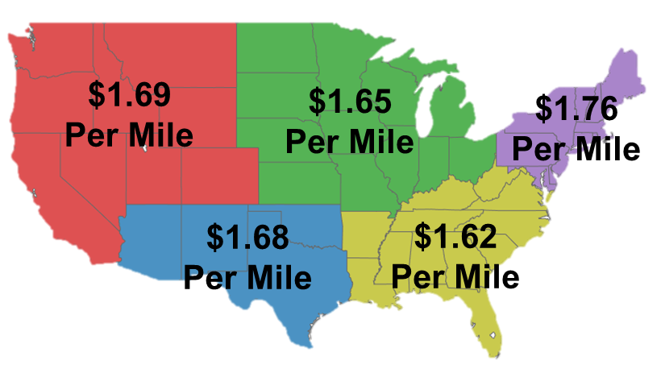

Figure 13: Regional division of United States [18]

The average marginal cost per mile has been divided to match the United States regional map published by US Department of Commerce Census Economics and Statistics Administration, U.S. Census Bureau. The average marginal Cost per mile for each region in United States is adapted from “*An Analysis of the Operational Costs of Trucking: A 2014 Update*” [15].

Table 6: Marginal cost of transportation per mile [15]

|  |  |  |  |  |
| --- | --- | --- | --- | --- |
|  | Average Marginal Cost per Mile by Region, 2013 | | |  |
| Midwest | Northeast | Southeast | Southwest | West |
| $1.65 | $1.76 | $1.62 | $1.68 | $1.69 |

# Assumption

## Assumptions

1. Truck driver will follow all safety regulations and tracker rules.
2. The truck will carry at least 80 dough trays of dough in single trip to the store.
3. Toppings distribution center is not taken into consideration
4. Stores stock demand + 1 day
5. Stores have adequate storage to hold 5 days’ supply.

# Problems

* Develop a web scraper to acquire the address, latitude, and longitude of all Domino stores within the continental US.
* Using any mapping API and Identify driving distance and time between suppliers and distribution centers.
* Based on the data provided in this case study and store data obtained in problem #1, determine the assignment of stores to distribution centers to meet demands of the stores at minimum transportation cost?
* How do you assign Domino’s distribution centers to the 38 Ardent mills to order flour from at minimize cost and meet flour demand?

# Bibliography

[1]. https://www.franchisehelp.com/industry-reports/pizza-industry-report/

[2]. Ardent Mills Location, http://www.ardentmills.com/communities/locations.html

[3]. “The Pie That Conquered America - The First Pizzeria in the United States” , http://pizza.com/the-first-pizzeria-in-the-united-states

[4]. “*Pizza Hut*”, https://en.wikipedia.org/wiki/Pizza_Hut

[5]. Hynum, Rick, “*The 2015 Pizza Power Report*” http://www.pmq.com/December-2014/Pizza-PowerThe-2015-Pizza-Power-Report/,December,2014

[6]. "*Domino's Pizza*", https://en.wikipedia.org/wiki/Domino%27s_Pizza

[7]. "*Domino's History*", https://biz.dominos.com/web/about-dominos-pizza/history

[8]. "*Domino's pizza world map*" https://commons.wikimedia.org/wiki/File:Domino%27s_pizza_world_map.PNG

[9]. https://jobs.dominos.com/dominos-careers/jobs/1174BR/delivery-driver-01109----2282-s.-main-street

[10]. “*Form 10-k*”, United States Securities and Exchange Commission, April, 2013, http://www.sec.gov/Archives/edgar/data/1286681/000119312513081957/d466015d10k.htm,

[11]."*Domino's Distribution Center Map*" http://www.thebraiser.com/pbs-dominos-illuminated-map/

[12]. "Planning, Sourcing, Replenishment Are Easy as (Pizza) Pie", http://www.supplychainbrain.com/content/industry-verticals/food-beverage/single-article-page/article/planning-sourcing-replenishment-are-easy-as-pizza-pie/

[13]. Sarsemba, Zhanibek, “Dominos supply chain“ https://www.academia.edu/8715376/Dominos_supply_chain

[14]. Schroeder, Eric, " Domino’s, Ardent Mills pizza partnership still strong" http://www.bakingbusiness.com/articles/news_home/Business/2015/06/Dominos_Ardent_Mills_pizza_par.aspx?ID=%7BEF3E37FE-D104-4001-973D-A266C8974E2D%7D

[15]. "An Analysis of the Operational Costs of Trucking: A 2014 Update", American Transportation Research Institute, September 2014.

[16] Drickhamer ,David ," Facility Design Trends: Changing Venue", http://mhlnews.com/facilities-management/facility-design-trends-changing-venue, Feb 1, 2006

[17]. http://www.ukessays.com/essays/business/comparing-the-supply-chains-of-dominos-and-pizza-hut-business-essay.php

[18]. “*Census Regions and Division of United States*”, U.S. Department of Commerce Economics and Statistics Administration U.S. Census Bureau

[19]. "*Why Domino’s Pizza is Not Worried About Rising Cheese Prices*" http://www.fastfoodmenuprices.com/dominos-pizza-worried-rising-cheese-prices/, September 14, 2014

[20]. <http://www.paradisetomato.com/article-press-release.aspx?id=66>

[21] C.H. Robinson. “*Trailer Equipment Guide*”. [www.chrobinson.com](http://www.chrobinson.com), 2012

[22] Coomes, Steve, “*A price increase is the answer, not a delivery fee*” <http://www.pizzamarketplace.com/news/a-price-increase-is-the-answer-not-a-delivery-fee/>

[23] Schroeder, Eric, “*Domino’s, Ardent Mills pizza partnership still strong*” <http://www.bakingbusiness.com/articles/news_home/Business/2015/06/Dominos_Ardent_Mills_pizza_par.aspx?ID=%7BEF3E37FE-D104-4001-973D-A266C8974E2D%7D&cck=1>

[24] “*Pizza Fun Facts*” ,http://pizza.com/fun-facts

[25]. <http://www.linkup.com/b/per-diem-cook-jobs-in-Fort-Worth-at-Domino's-Pizza.html>

[26] “*Copycat Domino’s Thin Crust Pizza Recipe*”, March 2, 2015 <http://www.layersofhappiness.com/copycat-dominos-thin-crust-pizza-recipe/>

[27] “*Leprino’s Food location*” .http://www.leprinofoods.com/locations/denver-colorado/

[28] “*Domino’s Distribution Center location*”https://jobs.dominos.com/dominos-careers/opportunities/supply-chain

[29] “40' REFRIGERATED TRAILERS”http://portablerefrigerationstorage.com/refrigerated-trailers/40-refrigerated-trailers/

[30] Jones, Adam, “*Domino’s: The Second-Largest Pizza Chain in the World*” <http://marketrealist.com/2015/03/dominos-second-largest-pizza-chain-world/>, Mar 26, 2015

[31] “*Paradise Tomato, Leprino named Domino's suppliers of the year*”,<http://www.pizzamarketplace.com/news/paradise-tomato-leprino-named-dominos-suppliers-of-the-year/>, June 3, 2002